Mental and Behavioral Disorders
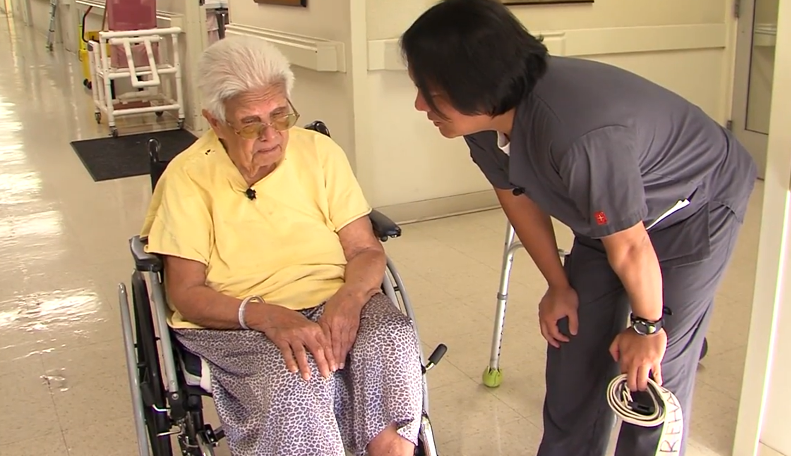

Watch
Assignment part 1:
- Ambulation Part 1: Patient Refuses
- Ambulation Part 2: Patient Complies
- Dementia Part 1: Grooming and Hygiene
- Dementia Part 2: Doffing Socks
- Dementia Part 3: Donning Socks
Assignment part 2:
- Self-Care: Dressing in Acute Care, Part 2
- Self-Care, Part 2: Washing at the Sink in Acute Care
- Self-Care, Part 3: Brushing Hair at the Sink in Acute Care
- Acute Care Part 5: Bed to Chair Transfer

Assignment Part 1: Questions
Watch each video on the ICE Video Library and complete the corresponding questions and SOAP Note.

Ambulation Part 1: Patient Refuses (15 points)
- Comment on the therapist’s approach – how did he maintain the client’s sense of dignity and respect and make the client feel comfortable? (3 points)
- Describe what you observed about their interactions. (3 points)
- Why do you think the patient did not want to participate? (3 points)
- What did you learn from this that you might use in treatment? (1 point)
- Write a SOAP Note (5 points)

Ambulation Part 2: Patient Complies (15 points)
- Comment on the therapist’s therapeutic use of self. (3 points)
- What assessments could you make on this client’s motor control from the videos? (3 points)
- Comment on how the therapist positions himself. (2 points)
- Describe 2 things that you learned from the video and state why you think it is important.
(2 points)
- Write a SOAP Note (5 points)

Dementia Part 1: Grooming and Hygiene (15 points)
- Comment on the therapist’s therapeutic use of self. (3 points)
- What assessments could you make on this client’s motor control from the videos? (2 points)
- Why do you think this simple ADL task is important in this patient’s treatment? How is this task therapeutic? (3 points)
- Describe 2 things that you learned from the video and state why you think they are important. (2 points)
- Write a SOAP Note (5 points)

Dementia Part 2: Doffing Socks (15 points)
- What assessments could you make on this client’s motor planning from the video? (3 points)
- What assessments could you make on this client’s cognitive status from the video? (3 points)
- Describe 2 things that you learned from the video and state why you think it is important. (3 points)
- What did you learn from this that you might use in treatment? (1 point)
- Write a SOAP Note (5 points)

Dementia Part 3: Donning Socks (15 points)
- Comment on the therapist’s rationale for trying the sock aid with this patient. (3 points)
- Discuss the therapist use of “frequent flier.” Do you think this facilitates or hinders the therapeutic relationship? (3 points)
- How do these videos relate to what you have learned or are learning in the program? (1 point)
- What other activities could you have this patient perform? List two activities and how you would organize the materials/tools? (3 points)
- Write a SOAP Note (5 points)

Assignment part 2
Watch the video on ICE Video Library and complete the corresponding questions including SOAP Notes and the video reflection questions.

In these 4 short videos, a young stroke survivor (BEN) exhibits behavioral problems while the therapists work on his cognitive, perceptual, and motor deficits in the context of ADL activities. See attached assignment to answer questions.

Self-Care: Dressing in Acute Care, Part 2 (15 points)
- What signs suggest that Ben is frustrated? (3 points)
- What do you think is the cause of Ben’s changes in behavior? For example, is it related to a medical condition, communication deficits, apraxia, fatigue, or impairment of body functions and structures? (2 points)
- Is it helpful for the therapist to let Ben continue to put the shirt on wrong? Why or why not? (3 points)
- How does the therapist increase awareness and incorporate use of the affected extremity? (2 points)
- Document this interaction using SOAP note format. (5 points)

Self-Care, Part 2: Washing at the Sink in Acute Care (15 points)
- What signs suggest that Ben is frustrated? (3 points)
- What do you think is the cause of Ben’s changes in behavior? For example, is it related to a medical condition, communication deficits, apraxia, fatigue, or impairment of body functions and structures? (2 points)
- What does the therapist do when Ben demonstrates frustration? (3 points)
- How does the therapist increase awareness and incorporate use of the affected extremity? (2 points)
- Document this interaction using SOAP note format. (5 points)

Self-Care, Part 3: Brushing Hair at the Sink in Acute Care (15 points)
- What signs suggest that Ben is frustrated? (3 points)
- What do you think is the cause of Ben’s changes in behavior? For example, is it related to a medical condition, communication deficits, apraxia, fatigue, or impairment of body functions and structures? (2 points)
- What does the therapist do when Ben demonstrates frustration? (3 points)
- How does the therapist increase awareness and incorporate use of the affected extremity? (2 points)
- Document this interaction using SOAP note format. (5 points)

Acute Care Part 5: Bed to Chair Transfer (15 points)
- What signs suggest that Ben is frustrated? (3 points)
- What do you think is the cause of Ben’s changes in behavior? For example, is it related to a medical condition, communication deficits, apraxia, fatigue, or impairment of body functions and structures? (2 points)
- What does the therapist do when Ben demonstrates frustration? (3 points)
- How does the therapist increase awareness and incorporate use of the affected extremity? (2 points)
- Document this interaction using SOAP note format. (5 points)

Video Reflection (65 points)
Thinking of all what you learned from watching all of Ben’s 4 videos, answer these questions:
- How do you think it will make you feel (as the therapist) when your client starts to get frustrated? (2 points)
- What are other ways you can modify the treatment session to meet the emotional needs of your client?
  - Activity demands (3 points)
  - Context (3 points)
  - Environment (3 points)
- Give specific examples of how you can ease a frustrated client.
  - Auditory (3 points)
  - Visual (3 points)
  - Tactile cues (3 points)

- Imagine working with this client in a busy rehab gym. How might a change in the client’s environment affect his performance? (3 points)

- What strategies should you use if your client becomes physically aggressive? (3 points)
- At what point should a treatment session be ended due to a client’s frustration? (3 points)
- How should you document a client’s frustration? (3 points)
- Describe how the therapist maximizes treatment outcomes by finding the just right challenge for the client’s level of skill and participation. (5 points)
- How could you better prepare and plan for a treatment session with a client who becomes easily frustrated? Discuss how you would use therapeutic use of self in this treatment session. (10 points)

- Discuss and justify 2 performance skills in each area. Indicate the video observed.
  - 2 Motor skills (4 points)
  - 2 Process skills (4 points)
  - 2 Social Interaction skills (4 points)
- a. How would you collaborate with the Ben (client), caregiver, family and significant others in monitoring and reassessing the effect of Ben’s occupational therapy intervention? (2 points)
b. Do you think Ben would benefit from continued or modified intervention? (2 points)
c. How would you communicate this to the occupational therapist? (2 points)

